Kaiden Love & Logan Bennett
IT 359
Code Documentation
Purpose: Explain how to set up Burp Suite Proxy for use of Intercept and Intruder to sniff an emulated Android mobile device on Android Studio.
The first part of setting up this project is to go to Android Studio and go to the Mobile Device Manager and create a mobile device to emulate. Set up the mobile device. For our project we used the Nexus 5x using API 28 and PIE imager. Then click run.
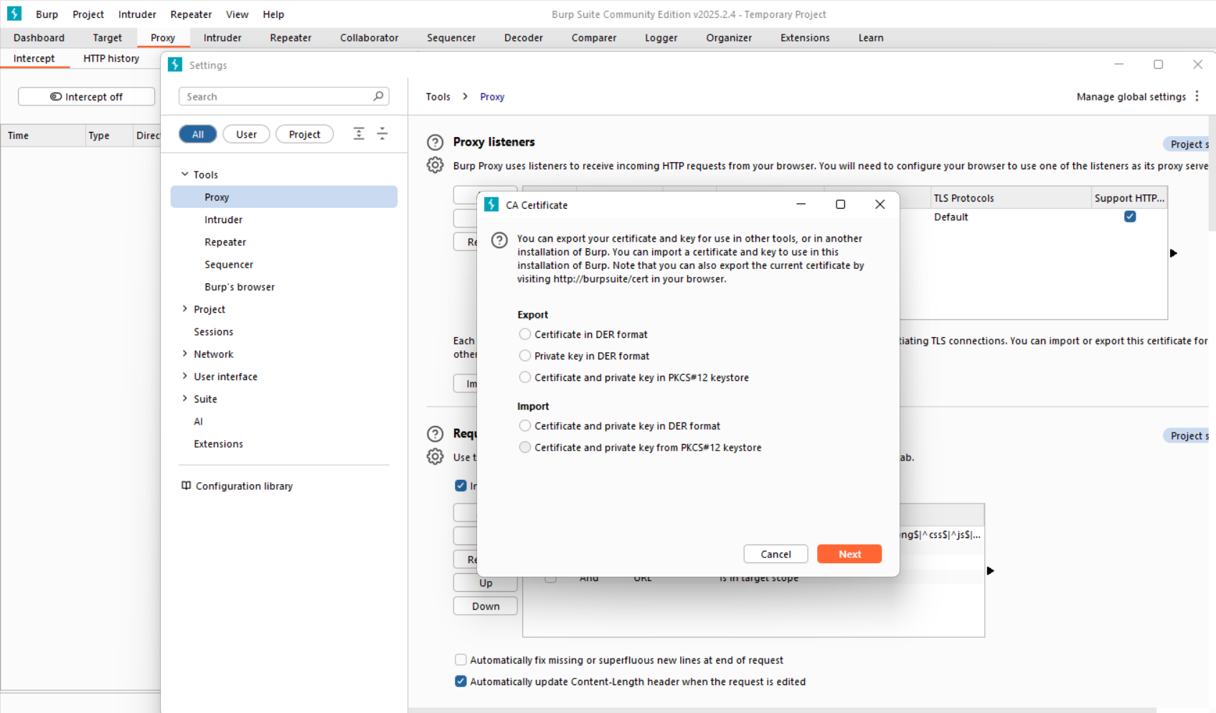
The next step is to run Burp Suite on default configuration. Click on the proxy header and click on settings. Click on the export certificate button to create your own certificate for the mobile device. Select the DER format and export.
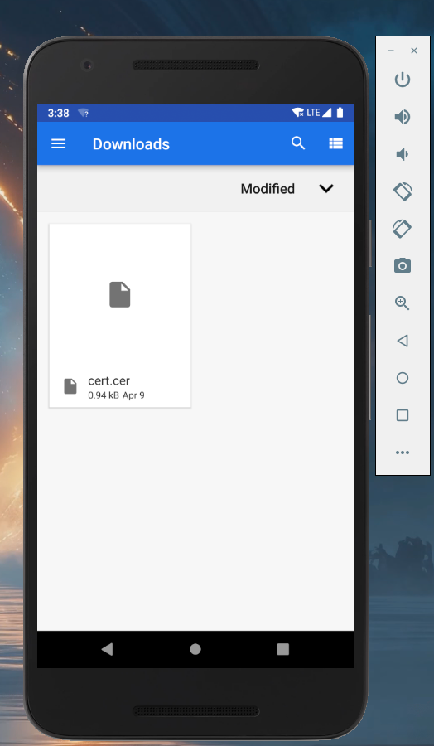
The next step is to navigate to the emulator and drag and drop the file from your file manager from your computer. Then navigate to the settings tab on the emulated mobile device and click on the security tab. Navigate to the encryption/decryption settings and click install certificate from SD. Click on the certificate and click install.
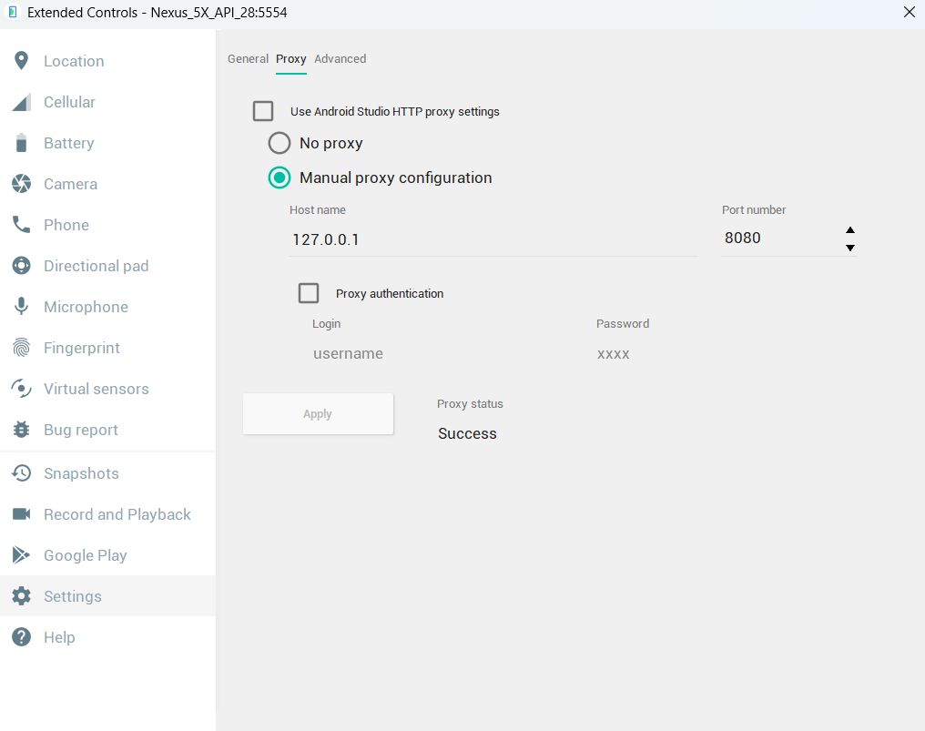
The next step requires you to navigate to the advanced settings on the emulator side bar. Go to settings, then proxy. Set up manual proxy configuration on the host name for Burp Suite using port 8080 for HTTP requests. Click Apply. You are now ready to use Intercept on Burp Suite.

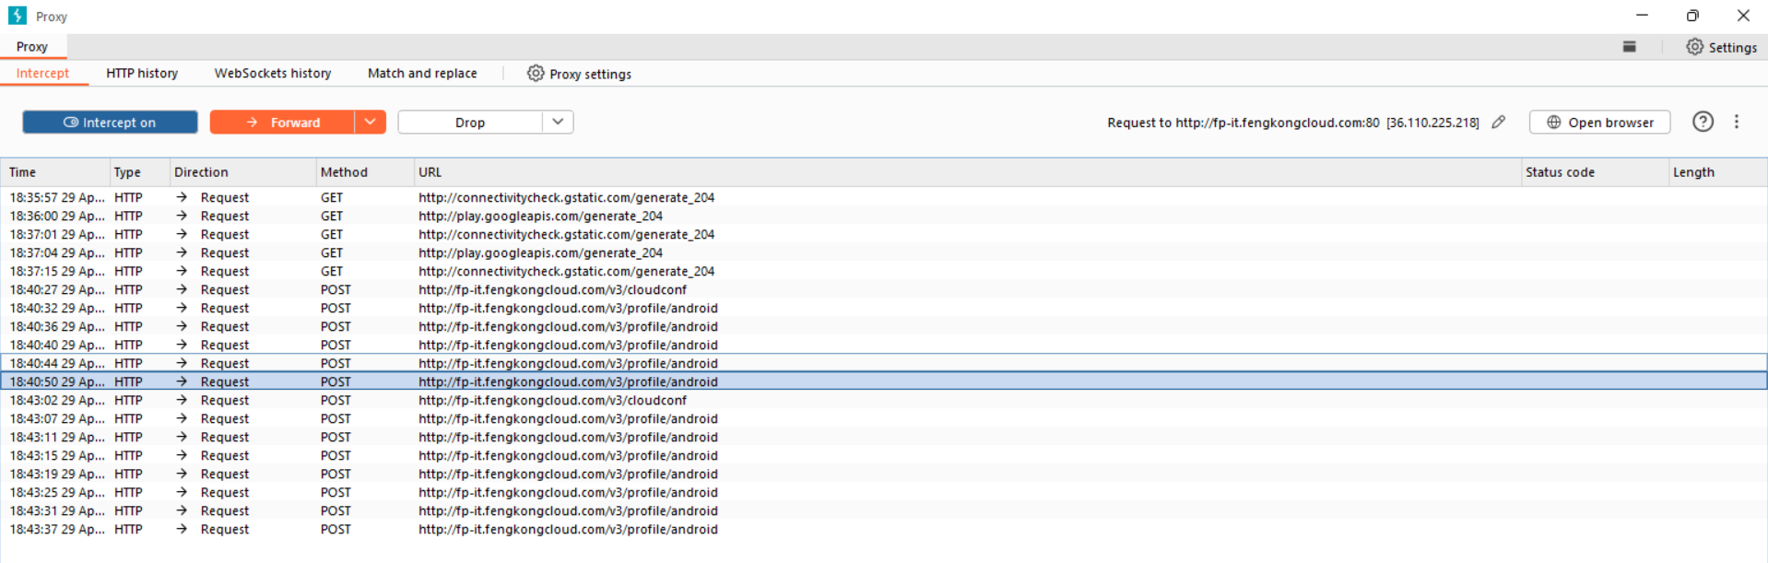
The next step is to open an application downloaded on the emulator and turn Intercept on and you will start sniffing packets on the proxy network. You can then choose any of the API links to send to intruder to start hacking with.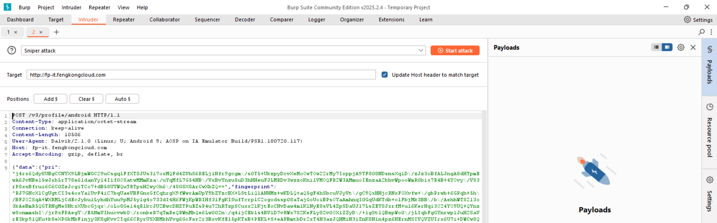
The next step is to use Intruder in any of the attack modes, sniper attack is pictured. Then highlight the payloads you want to test and click add. Finally, start the attack.

